You are going to write a PHP code to connect and create a database called InventoryChain. Make sure to include cofig.php file. Import the .sql file to create and populate all the tables. You are going to perform the following queries and display the results using datatable plug in. Your web page should have a ‘nav bar’ that lists all the exercises and when a user clicks on a particular exercise, it takes him/her to the data table that is the result of that query. It will also display the actual question, the sql query, and the total number of records that the query produced, before you print out the table for each exercise as demonstrated in class.

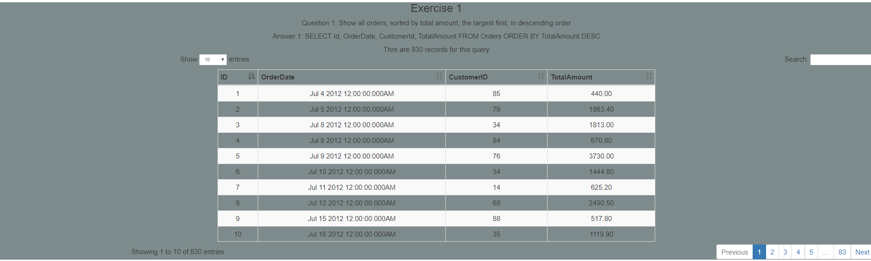

**Queries:**

1. Show all orders, sorted by total amount, the largest first, in descending order
2. List the number of customers in each country
3. List the number of customers in each country. Only include countries with more than 10 customers.
4. List total customers in each country. Display results with easy to understand column

headers.

5. List all orders with customer information

6. List all suppliers in **reverse** alphabetical order

7. Copy all Canadian suppliers into the Customer table

8. List all orders that not between $50 and $15000

Come up with two more queries that uses the keyword ‘like’ and the aggregate function ‘Avg’ and print out the datatables. Also add these two exercises, Ex 9 and 10, to your nav bar.

Format your page using Bootstrap with proper headings, color and placement as demonstrated in class. Document your code and submit it on moodle by the due date.